**Git questions??? Class 01 and Class 02**

**What is git?**

**What is git bash??**

**What is git hub???**

**What is version?**

**Why do we need git?? To save time, to save memory, to save being mess up**

**Why do You need to configure git;**

**Give commands to config git?**

**--git config --global user.name “babarali”** ------ 🡪 git config space – double dash space user.name space “username”

**--git config --global user.email** [**babaraliengineer32@gmail.com**](mailto:babaraliengineer32@gmail.com)

**Git is a 3 stage architecture**

1.working directory -- all java files are present the place where we add all the files/codes/folder which we want to send to the repository

2.staging area -- add all files which you want to send in repo. checkpoint

3. repository -- to store the commits. Is to store data in repository

**Why we don’t create repository inside the src or .idea or other folder ???**

it will not track the other files.

**What is git ignore file?? – the files which you do not want to store in repo, unnecessary files**

**how create a git ignore file, what is the command to create git ignore file.????**

**-------------------- touch .gitignore ---------------**

to see all the files inside the staging area there is a special command ---

----------------------------- git ls-files------------------------------

**How remove the file if it accidently added in staging area.**

**-----git rm –cached filename**

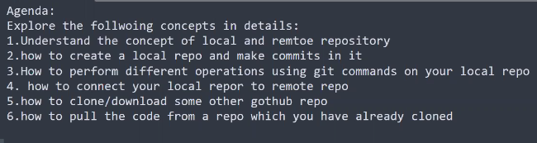

-------------------------------------------------------------------------------------------------------------------------------------------------------------------------------------------------------------------------------------------------------------------------------------------------------------------------------------------------------------------------------------------------------------------------------------------------------------------------------------------------------------------------------------------------------------------------------------------------------------------------------------------------------------------------------------------------------------------------------------------------------------------------------------------------------------------------------------------------------------------------------------------------------

**Git class 03 and Class 04**

**What is github ?????**

**Central repository on internet to have backup of our code Is called github.**

**Why we should use git hub ? -- when there was not github you will use , email, whatsapp, and other app , it was very difficult to share your code,**

**what is the importance of that ???**

**What other task you can do by using github??? work with collaboration. Mean with team**

**How you will send code from local to central repository / from git to github.??**

**What is git clone????????**

Clone mean making a copy

**What is difference in download and cloning git.??????**

Download from github mean it download only one latest or updated file from the github repository, and not download all the files.

------------clone mean it download the complete repository from the central repository. ----------

**Why clone is important in git clone ?????????**

**What is metho to clone??**

**What is fetch command ?? it tells the state of remote repo, is there any update or not.**

**What is pull command? -- to download the changes from central repo**

**What is difference in pull and push commands.**

**What is the command to see files in staging area, in repository, in working directory??**

**--git ls-files >>>>>> file in staging area**

**-- git status >>>>>>> working directory**

**-- git log >>>>>> in repo**

There is condition in git repository you only can push the files or code when central repository is empty or when central and local repository are at same level.

**How remove the file if it accidently added in staging area.??**

**To remove any file from the staging area**

**--git rm –cached filename**

**Git diff command , show us the difference in working directory and staging area , add line in intellij and then run this command.**

**What is method to clone?**

**To show the difference of files which are not same in staging area and repo , command is**

**--git diff –staged ---**

**If you delete src folde inside working directory then you can back it , there is command**

**--git restore src---**

**--------------------------------------------------------------------------------------------------------------------------------------------------------------------------------------------------------------------------------------------------------------------------------------------------------------------------------------------------------------------------------------------------------------------------------------------------------------------------------------------------------------------------------------------------------------------------------------------------**

**Class git 05**

**What is git stash ???** stash is a stashing area which saves your uncommitted (both

staged and un-staged) changes temporarily for later use.

**2.** it also revert the condition of working directory back to the last commit(it also changes the staging area to the last commit) mean both to become at same level synchronize.

**Why we use stash ,why we need stash ???**

1. if the code is not final yet , temporarily save some where else

2. you don’t want to make redundant commits

**What is command to see status of stash??**

**---git stash list-----**

**What is command to bring data back from stash??**

**--git stash apply 1 ------ here 1 is index.**

**What is command to delete stash commit??**

**--git stash drop----**

**If you have stash apply and you want to use previous stash , what will you do??**

**1. commit the current stash to repo**

**2. or stash the current stash , and pull back the desired stash.**

**When a conflict occurs??**

**There are many reason of conflict.**

**How data bring back from stash storage area????????**

**If you make changes in code, but you don’t know what was the updated code how will you know. ??? stash the changing code just, it will revert back to latest commit.**

**---git stash -m “message”**

**--git stash apply 1**

**--git stash pop 4 --- this command first take back the stash in working directory and then delete this commit inside the stashing area.**

**--git stash drop 1**

**-- git stash pop – to delete file**

**-- git stash list----**

**In order to work on untracked files in stash what is command???**

**What is difference in git stash drop and git stash pop commands??? Both delete stash commit.**

**git stash pop 4 --- this command first take back the stash in working directory and then delete this commit inside the stashing area.**

**--git stash drop 1 – it delete stash do not take back it into working directory.**

**What is difference in git stash -m, and git stash -u commands???**

**--git stash -u --------- this command is used to add untracked files inside stash area..**

**-- git stash -m --- is used to add tracked files.**

??? If you have stashed applied and you want to apply previous stash how will do ????

1. first you will stash previously applied stash and then you will apply new stash

**When does conflict occur in stash??????** When there is tracked file is present in working directory and your pulling the code from stash area back.

**--------------------------------------------------------------------------------------------------------------------------------------------------------------------------------------------------------------------------------------------------------------------------------------------------------------------------------------------------------------------------------------------------------------------------------------------------------------------------------**

**CLASS 06 GIT CLASS 06 GIT**

**What is branch in git??**

In Git, a branch is a new separate version of the main repository or main branch.

**Why we do need branches??**

Because we do not want to change/alter the main branch.

**What is topic branch???**

A "topic branch" is a temporary branch created to work on a specific topic or feature.

It includes the latest commit made to the main branch, also known as the "master" branch.

**What is the command to move head at previous commit ??**

**---git log 2----- last 5 commits you can see only.**

**What is command to create new branch??**

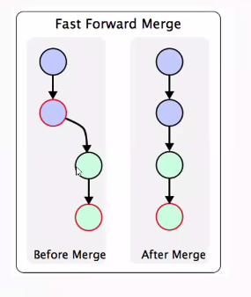

**What is command to switch branch??**

**Who merge branch ???**

**1. first you move to the parent branch**

**2. second use merge command ---git merge “name child branch”-------**

**What is the command to see all the branches ??**

**--git branch -a------------ A mean all.**

**What is command to delete a branch??????**

---------git branch -d Bug Fix-------------------this will delete branch

**What is fast-forward strategy??????**

Fast forward is a merging technique which git uses to merge the commits or branches.

In this the last commit of the parent branch is merged with first commit of child branch.

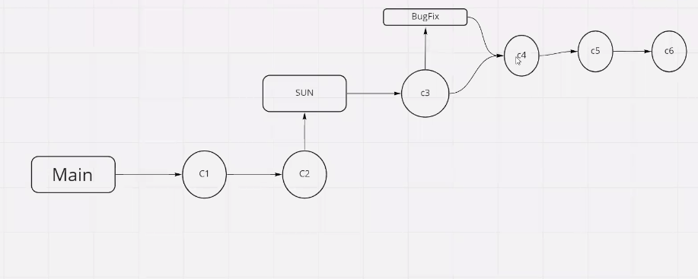

**How merge branch??**

**Create branch**

**Switch branch**

**Make commit of branch, may be in local or may be in remote github.**

**1. first create branch**

**2. switch to branch**

**3. commit the branch**

**4. then you can merge branch**

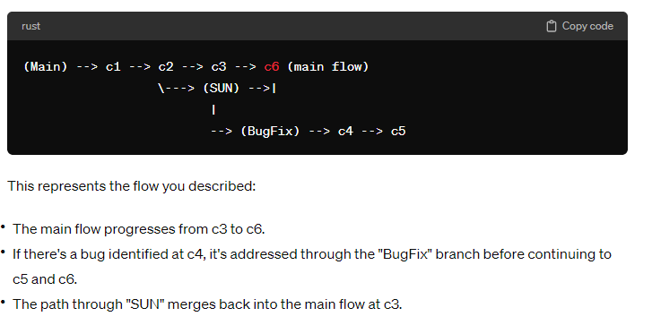

**When fast forward merge happen??**

**The fast forward merge is only happened when the history of last commit of parent branch is not updated.**

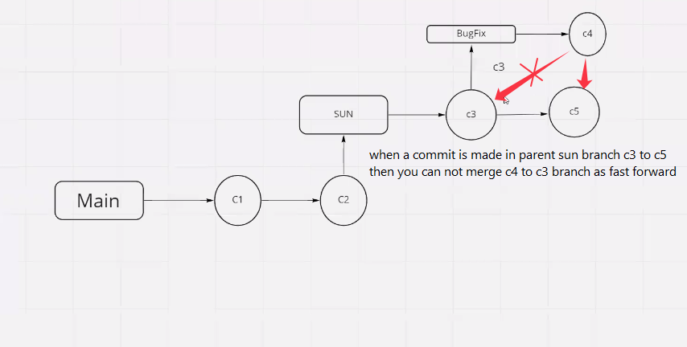

**The following images are complete solar branch system in git bash all commands.**

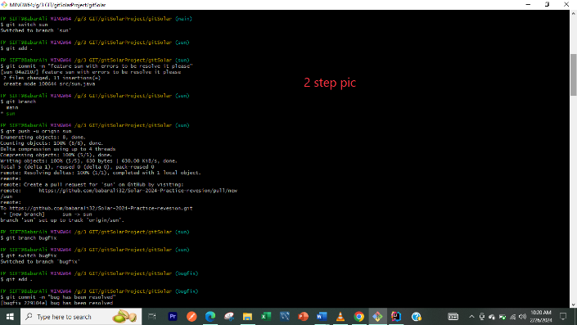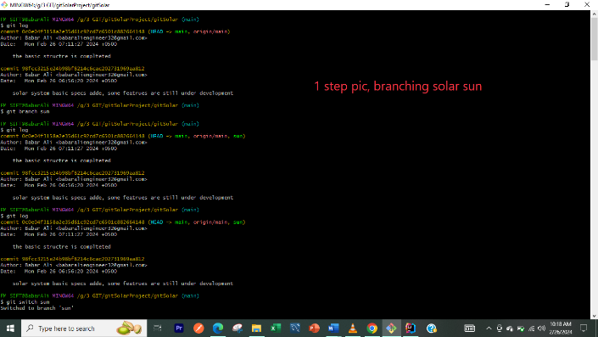

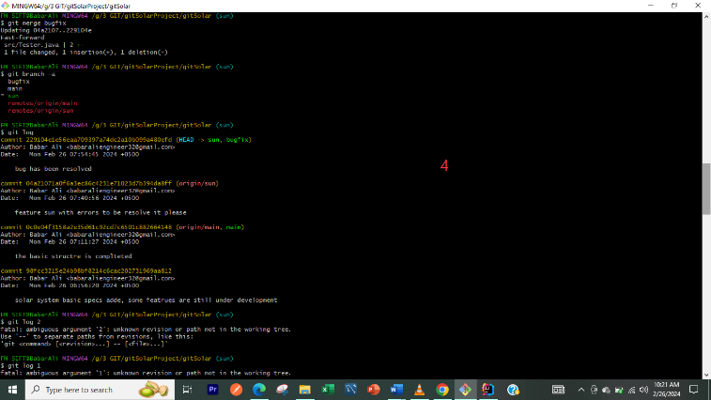

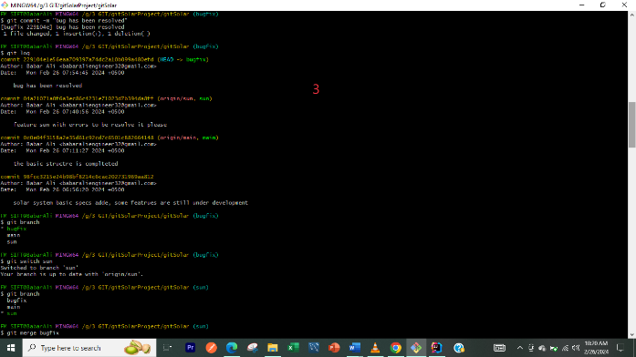

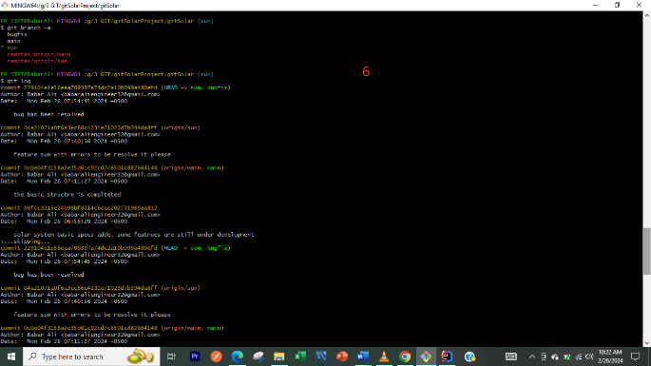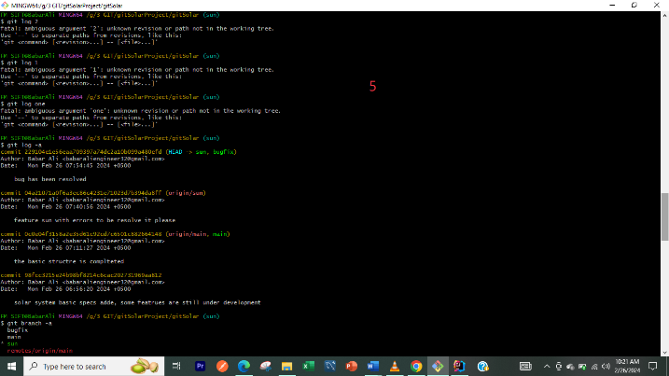

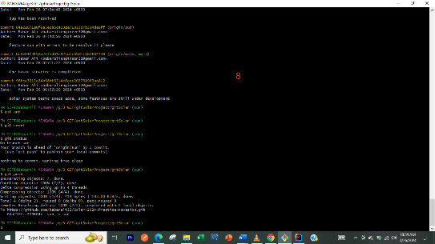

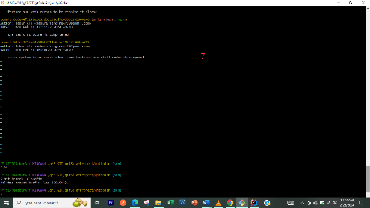

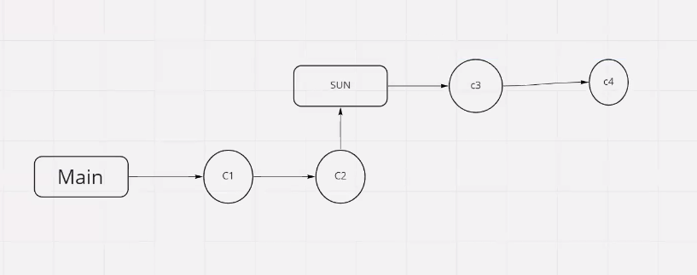

**You have merged the bug fix branch in sun branch which is commit 4. Now you must commit this c4 in git hub then it will added.**

**Is there conflict can occur in fast forward?? answer is no.**

Conflict only occurs when main branch is merged with child branch.

**When you clone git, only main branch is downloaded and other branches are not downloaded why ???**

Because if you want to create new feature on main branch then you do not need to download other branches, git is smart he thinks other branches are redundant for you

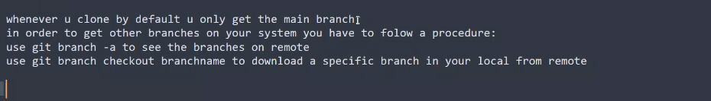

Is this necessary to occur conflict when there is no fast forward ??

No this is not necessary , there may be conflict or not.

Conflict occurs only when same line of code are changed , if new classes are created then there is no conflict.

------------------------------------------------------------------------------------------------------------------------------------------------------------------------------------------------------------------------------------------------------------------------------------------------------------------------------------------------------------------------------------------------------------------------------------------------------------------------------------------------------------------------------------------------------------------------------------------------------------------------------------------------------------------------------------------------------------------------------------------------------------------------------------------------------------------------------------------------------------------------

**CLASS 06 GIT DATE;28-02-2024**

**What is recursive merge???**

Recursive merge is a technique which git uses to merge the commits or branches.

**How three-way merge happened???**

A three-way merge is a merging strategy used by Git when combining changes from two different branches. It involves three commits:

When there occur no fast forward then there occur three-way merge.

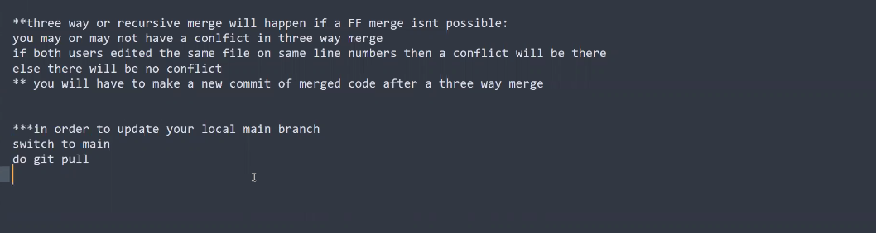

**When conflict occur???**

When same line changed by two different persons.